Stat.653 Project

Nurahmet Maimaitiyiming

May 1st,2020

### I have collected a set of documents that definitely relate to four separate topics, then perform topic modeling to see whether the algorithm can correctly distinguish the four groups.

## Books selected

* *Birds Every Child Should Know* by Neltje Blanchan (Animal Category)
* *Pride and Prejudice* by by Jane Austen
* *Houses and House-Life of the American Aborigines* by Lewis Henry Morgan (History Category)
* *Musicians of To-Day*  by Romain Rolland (Music Category)

## Retrieving the text of these four books using the gutenbergr package

titles <- c("Birds Every Child Should Know", "Pride and Prejudice",  
 "Houses and House-Life of the American Aborigines", "Musicians of To-Day")

library(gutenbergr)  
library(ggplot2)  
library(tidyverse)

## -- Attaching packages ------------------------------------------------- tidyverse 1.3.0 --

## v tibble 3.0.0 v dplyr 0.8.5  
## v tidyr 1.0.2 v stringr 1.4.0  
## v readr 1.3.1 v forcats 0.5.0  
## v purrr 0.3.3

## -- Conflicts ---------------------------------------------------- tidyverse_conflicts() --  
## x dplyr::filter() masks stats::filter()  
## x dplyr::lag() masks stats::lag()

books<- gutenberg_works(title %in% titles) %>%  
 gutenberg_download(meta_fields = "title")

## Determining mirror for Project Gutenberg from http://www.gutenberg.org/robot/harvest

## Using mirror http://aleph.gutenberg.org

As pre-processing, divided these into chapters, use tidytext’s unnest_tokens() to separate them into words, then remove stop_words. We’re treating every chapter as a separate “document”, each with a name like Birds Every Child Should Know_1 or Musicians of To-Day_11.

library(stringr)  
library(dplyr)  
library(tidyr)  
library(tidytext)  
  
# divide into documents, each representing one chapter  
by_chapter <-books %>%  
 group_by(title) %>%  
 mutate(chapter = cumsum(str_detect(text, regex("^chapter ", ignore_case = TRUE)))) %>%  
 ungroup() %>%  
 filter(chapter > 0) %>%  
 unite(document, title, chapter)  
  
# split into words  
by_chapter_word <- by_chapter %>%  
 unnest_tokens(word, text)  
  
# find document-word counts  
word_counts <- by_chapter_word %>%  
 anti_join(stop_words) %>%  
 count(document, word, sort = TRUE) %>%  
 ungroup()

## Joining, by = "word"

word_counts

## # A tibble: 69,284 x 3  
## document word n  
## <chr> <chr> <int>  
## 1 Musicians of To-Day_1 music 519  
## 2 Musicians of To-Day_1 art 242  
## 3 Musicians of To-Day_1 footnote 238  
## 4 Musicians of To-Day_1 musical 196  
## 5 Musicians of To-Day_1 french 176  
## 6 Musicians of To-Day_1 time 167  
## 7 Musicians of To-Day_1 life 162  
## 8 Musicians of To-Day_1 de 153  
## 9 Musicians of To-Day_1 wagner 152  
## 10 Houses and House-Life of the American Aborigines_12 tribes 146  
## # ... with 69,274 more rows

### LDA on chapters

Right now data frame word_counts is in a tidy form, with one-term-per-document-per-row, but the topicmodels package requires a DocumentTermMatrix.We can cast a one-token-per-row table into a DocumentTermMatrix with tidytext’s cast_dtm().

library(topicmodels)  
chapters_dtm <- word_counts %>%  
 cast_dtm(document, word, n)  
  
chapters_dtm

## <<DocumentTermMatrix (documents: 104, terms: 18831)>>  
## Non-/sparse entries: 69284/1889140  
## Sparsity : 96%  
## Maximal term length: 23  
## Weighting : term frequency (tf)

Useing the LDA() function to create a four-topic model. In this case we know we’re looking for four topics because there are four books; in other problems we may need to try a few different values of k.

chapters_lda <- LDA(chapters_dtm, k = 4, control = list(seed = 1234))  
chapters_lda

## A LDA_VEM topic model with 4 topics.

We can examine per-topic-per-word probabilities.

chapter_topics <- tidy(chapters_lda, matrix = "beta")  
chapter_topics

## # A tibble: 75,324 x 3  
## topic term beta  
## <int> <chr> <dbl>  
## 1 1 music 1.61e- 2  
## 2 2 music 5.88e- 4  
## 3 3 music 3.22e- 4  
## 4 4 music 6.47e- 5  
## 5 1 art 7.52e- 3  
## 6 2 art 3.72e-44  
## 7 3 art 8.06e- 5  
## 8 4 art 5.09e- 4  
## 9 1 footnote 7.39e- 3  
## 10 2 footnote 1.88e-86  
## # ... with 75,314 more rows

Notice that this has turned the model into a one-topic-per-term-per-row format. For each combination, the model computes the probability of that term being generated from that topic.

We could use dplyr’s top_n() to find the top 5 terms within each topic.

top_terms <- chapter_topics %>%  
 group_by(topic) %>%  
 top_n(5, beta) %>%  
 ungroup() %>%  
 arrange(topic, -beta)  
  
top_terms

## # A tibble: 20 x 3  
## topic term beta  
## <int> <chr> <dbl>  
## 1 1 music 0.0161   
## 2 1 art 0.00752  
## 3 1 footnote 0.00739  
## 4 1 musical 0.00608  
## 5 1 french 0.00546  
## 6 2 birds 0.00916  
## 7 2 bird 0.00840  
## 8 2 white 0.00630  
## 9 2 nest 0.00567  
## 10 2 tree 0.00513  
## 11 3 elizabeth 0.0160   
## 12 3 darcy 0.0100   
## 13 3 bennet 0.00789  
## 14 3 miss 0.00760  
## 15 3 jane 0.00706  
## 16 4 houses 0.00950  
## 17 4 tribes 0.00876  
## 18 4 footnote 0.00824  
## 19 4 feet 0.00809  
## 20 4 house 0.00751

## visualizing the top 5 terms with ggplot2

library(ggplot2)  
  
top_terms %>%  
 mutate(term = reorder_within(term, beta, topic)) %>%  
 ggplot(aes(term, beta, fill = factor(topic))) +  
 geom_col(show.legend = FALSE) +  
 facet_wrap(~ topic, scales = "free") +  
 coord_flip() +  
 scale_x_reordered()

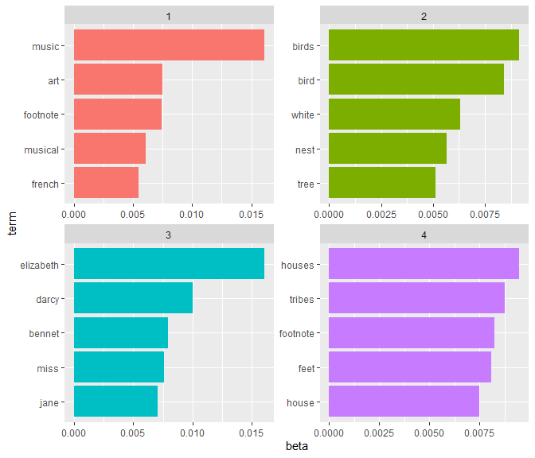

The terms that are most common within each topic

### Per-document classification

Each document in this analysis represented a single chapter. Thus, we may want to know which topics are associated with each document. Can we put the chapters back together in the correct books? We can find this by examining the per-document-per-topic probabilities, $γ$ (“gamma”).

chapters_gamma <- tidy(chapters_lda, matrix = "gamma")  
chapters_gamma

## # A tibble: 416 x 3  
## document topic gamma  
## <chr> <int> <dbl>  
## 1 Musicians of To-Day_1 1 1.00   
## 2 Houses and House-Life of the American Aborigines_12 1 0.00000167  
## 3 Houses and House-Life of the American Aborigines_19 1 0.00307   
## 4 Houses and House-Life of the American Aborigines_15 1 0.00000202  
## 5 Houses and House-Life of the American Aborigines_20 1 0.00000286  
## 6 Birds Every Child Should Know_9 1 0.00000390  
## 7 Houses and House-Life of the American Aborigines_18 1 0.00862   
## 8 Houses and House-Life of the American Aborigines_16 1 0.00000260  
## 9 Houses and House-Life of the American Aborigines_23 1 0.00000208  
## 10 Houses and House-Life of the American Aborigines_14 1 0.00000421  
## # ... with 406 more rows

First we re-separate the document name into title and chapter, after which we can visualize the per-document-per-topic probability for each

chapters_gamma <- chapters_gamma %>%  
 separate(document, c("title", "chapter"), sep = "_", convert = TRUE)  
  
chapters_gamma

## # A tibble: 416 x 4  
## title chapter topic gamma  
## <chr> <int> <int> <dbl>  
## 1 Musicians of To-Day 1 1 1.00   
## 2 Houses and House-Life of the American Aborigines 12 1 0.00000167  
## 3 Houses and House-Life of the American Aborigines 19 1 0.00307   
## 4 Houses and House-Life of the American Aborigines 15 1 0.00000202  
## 5 Houses and House-Life of the American Aborigines 20 1 0.00000286  
## 6 Birds Every Child Should Know 9 1 0.00000390  
## 7 Houses and House-Life of the American Aborigines 18 1 0.00862   
## 8 Houses and House-Life of the American Aborigines 16 1 0.00000260  
## 9 Houses and House-Life of the American Aborigines 23 1 0.00000208  
## 10 Houses and House-Life of the American Aborigines 14 1 0.00000421  
## # ... with 406 more rows

# reorder titles in order of topic 1, topic 2, etc before plotting  
chapters_gamma %>%  
 mutate(title = reorder(title, gamma * topic)) %>%  
 ggplot(aes(factor(topic), gamma)) +  
 geom_boxplot() +  
 facet_wrap(~ title)

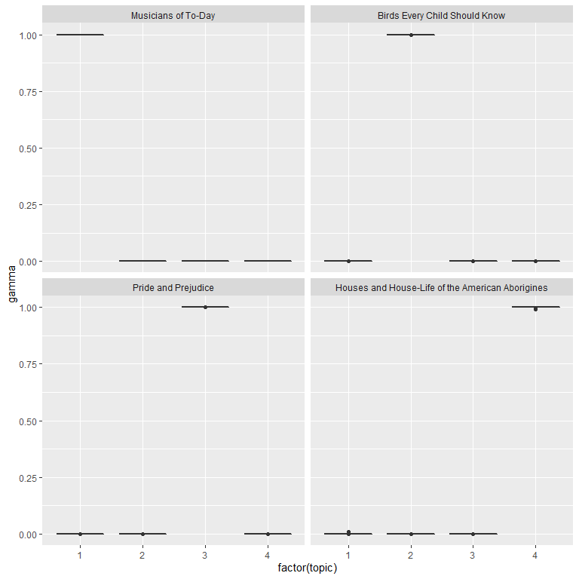

The gamma probabilities for each chapter within each book

chapter_classifications <- chapters_gamma %>%  
 group_by(title, chapter) %>%  
 top_n(1, gamma) %>%  
 ungroup()  
  
chapter_classifications

## # A tibble: 104 x 4  
## title chapter topic gamma  
## <chr> <int> <int> <dbl>  
## 1 Musicians of To-Day 1 1 1.00  
## 2 Birds Every Child Should Know 9 2 1.00  
## 3 Birds Every Child Should Know 16 2 1.00  
## 4 Birds Every Child Should Know 1 2 1.00  
## 5 Birds Every Child Should Know 4 2 1.00  
## 6 Birds Every Child Should Know 8 2 1.00  
## 7 Birds Every Child Should Know 14 2 1.00  
## 8 Birds Every Child Should Know 2 2 1.00  
## 9 Birds Every Child Should Know 5 2 1.00  
## 10 Birds Every Child Should Know 7 2 1.00  
## # ... with 94 more rows

We can then compare each to the “consensus” topic for each book (the most common topic among its chapters) and see which were most often misidentified.

book_topics <- chapter_classifications %>%  
 count(title, topic) %>%  
 group_by(title) %>%  
 top_n(1, n) %>%  
 ungroup() %>%  
 transmute(consensus = title, topic)  
  
chapter_classifications %>%  
 inner_join(book_topics, by = "topic") %>%  
 filter(title != consensus)

## # A tibble: 0 x 5  
## # ... with 5 variables: title <chr>, chapter <int>, topic <int>, gamma <dbl>,  
## # consensus <chr>

### By word assignments: augment

assignments <- augment(chapters_lda, data = chapters_dtm)  
assignments

## # A tibble: 69,284 x 4  
## document term count .topic  
## <chr> <chr> <dbl> <dbl>  
## 1 Musicians of To-Day_1 music 519 1  
## 2 Birds Every Child Should Know_9 music 2 2  
## 3 Houses and House-Life of the American Aborigines_22 music 3 4  
## 4 Pride and Prejudice_18 music 2 3  
## 5 Birds Every Child Should Know_4 music 5 2  
## 6 Birds Every Child Should Know_2 music 2 2  
## 7 Pride and Prejudice_10 music 2 3  
## 8 Pride and Prejudice_8 music 1 3  
## 9 Birds Every Child Should Know_10 music 4 2  
## 10 Birds Every Child Should Know_13 music 1 2  
## # ... with 69,274 more rows

assignments <- assignments %>%  
 separate(document, c("title", "chapter"), sep = "_", convert = TRUE) %>%  
 inner_join(book_topics, by = c(".topic" = "topic"))  
  
assignments

## # A tibble: 69,284 x 6  
## title chapter term count .topic consensus   
## <chr> <int> <chr> <dbl> <dbl> <chr>   
## 1 Musicians of To-Day 1 music 519 1 Musicians of To-Day   
## 2 Birds Every Child Shoul~ 9 music 2 2 Birds Every Child Should~  
## 3 Houses and House-Life o~ 22 music 3 4 Houses and House-Life of~  
## 4 Pride and Prejudice 18 music 2 3 Pride and Prejudice   
## 5 Birds Every Child Shoul~ 4 music 5 2 Birds Every Child Should~  
## 6 Birds Every Child Shoul~ 2 music 2 2 Birds Every Child Should~  
## 7 Pride and Prejudice 10 music 2 3 Pride and Prejudice   
## 8 Pride and Prejudice 8 music 1 3 Pride and Prejudice   
## 9 Birds Every Child Shoul~ 10 music 4 2 Birds Every Child Should~  
## 10 Birds Every Child Shoul~ 13 music 1 2 Birds Every Child Should~  
## # ... with 69,274 more rows

library(scales)

##   
## Attaching package: 'scales'

## The following object is masked from 'package:purrr':  
##   
## discard

## The following object is masked from 'package:readr':  
##   
## col_factor

assignments %>%  
 count(title, consensus, wt = count) %>%  
 group_by(title) %>%  
 mutate(percent = n / sum(n)) %>%  
 ggplot(aes(consensus, title, fill = percent)) +  
 geom_tile() +  
 scale_fill_gradient2(high = "red", label = percent_format()) +  
 theme_minimal() +  
 theme(axis.text.x = element_text(angle = 90, hjust = 1),  
 panel.grid = element_blank()) +  
 labs(x = "Book words were assigned to",  
 y = "Book words came from",  
 fill = "% of assignments")

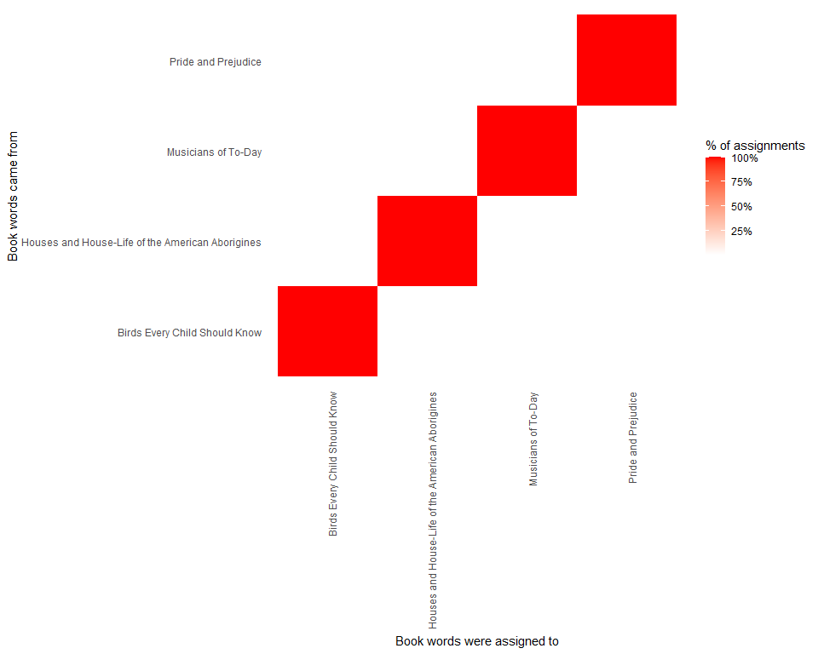

Confusion matrix showing where LDA assigned the words from each book.

What were the most commonly mistaken words?

wrong_words <- assignments %>%  
 filter(title != consensus)  
  
wrong_words

## # A tibble: 29 x 6  
## title chapter term count .topic consensus   
## <chr> <int> <chr> <dbl> <dbl> <chr>   
## 1 Houses and House-Life of the A~ 19 paris 1 1 Musicians of ~  
## 2 Houses and House-Life of the A~ 19 performa~ 1 1 Musicians of ~  
## 3 Houses and House-Life of the A~ 17 performa~ 1 1 Musicians of ~  
## 4 Houses and House-Life of the A~ 17 scene 1 1 Musicians of ~  
## 5 Houses and House-Life of the A~ 17 february 1 1 Musicians of ~  
## 6 Houses and House-Life of the A~ 18 phrases 1 1 Musicians of ~  
## 7 Houses and House-Life of the A~ 19 september 1 1 Musicians of ~  
## 8 Houses and House-Life of the A~ 18 atmosphe~ 1 1 Musicians of ~  
## 9 Houses and House-Life of the A~ 17 admirable 1 1 Musicians of ~  
## 10 Houses and House-Life of the A~ 17 clearness 1 1 Musicians of ~  
## # ... with 19 more rows

wrong_words %>%  
 count(title, consensus, term, wt = count) %>%  
 ungroup() %>%  
 arrange(desc(n))

## # A tibble: 28 x 4  
## title consensus term n  
## <chr> <chr> <chr> <dbl>  
## 1 Houses and House-Life of the American Abo~ Musicians of To-~ performan~ 2  
## 2 Houses and House-Life of the American Abo~ Musicians of To-~ 1848 1  
## 3 Houses and House-Life of the American Abo~ Musicians of To-~ admirable 1  
## 4 Houses and House-Life of the American Abo~ Musicians of To-~ atmosphere 1  
## 5 Houses and House-Life of the American Abo~ Musicians of To-~ born 1  
## 6 Houses and House-Life of the American Abo~ Musicians of To-~ clearness 1  
## 7 Houses and House-Life of the American Abo~ Musicians of To-~ confines 1  
## 8 Houses and House-Life of the American Abo~ Musicians of To-~ conscious 1  
## 9 Houses and House-Life of the American Abo~ Musicians of To-~ discovers 1  
## 10 Houses and House-Life of the American Abo~ Musicians of To-~ faint 1  
## # ... with 18 more rows